|  |  |
| --- | --- |
| **Elevator** | |
|  | **2** |

|  |  |  |  |  |  |  |
| --- | --- | --- | --- | --- | --- | --- |
| **PARTS** | Base Plate  http://images.studica.com/images/product/fischertechnik/86grundplatte.jpgx1 | mySTEM Board  mySTEM™ Project Board for NI myDAQx1 | NI myDAQ  NI myDAQ for Secondary Schoolsx1 | DC Motor  32293: S-MOTOR 6-9V x1 | Gearbox  31078: Motor Reducing Gearbox Black x1 | Rack & Pinion  37351: RACK & PINION 60  x2 |
| Girder 120  36293: ANGLE GIRDER 120 BLACKx8 | Block 30  32880: BUILDING BLOCK 30 WITH BORE x10 | Spring Cam  31982: SPRING CAM x3 | Hinged Block  31436: HINGED BLOCK CLAW x1 | Angle Block  38423: ANGLE BLOCK 10 X 15 X 15 x1 | Block 15  32881: BUILDING BLOCK 15 x15 |
| Statics Block  35076: STATICS BUILDING BLOCK x3 | Building Plate  38428: BUILDING PLATE 15X30X5 WITH 3 GROOVES x1 | Limit Switch  37783: MINI-SWITCHx5 | Rivet 4MM  36323: SINGLE RIVET 4 MM RED x9 | Building Block 5  37237: BUILDING BLOCK 5 x2 | Building Block  37468: BUILDING BLOCK 7,5 x2 |
| Link 30  31061: LINK 30x2 | Bottom plate 30 X 90  32859: BOTTOM PLATE 30 X 90 RED x4 | Mounting Plate with Peg 15 X 45  38241: MOUNTING PLATE WITH PEG 15 X 30 RED x2 | Building Plate 15X30X5  38428: BUILDING PLATE 15X30X5 WITH 3 GROOVES x1 | Link 15  31060: LINK 15 x2 |  |

|  |
| --- |
| Assemble |

**Use two Building Block with a link 15 and attach it to a hinge block using spring cam**

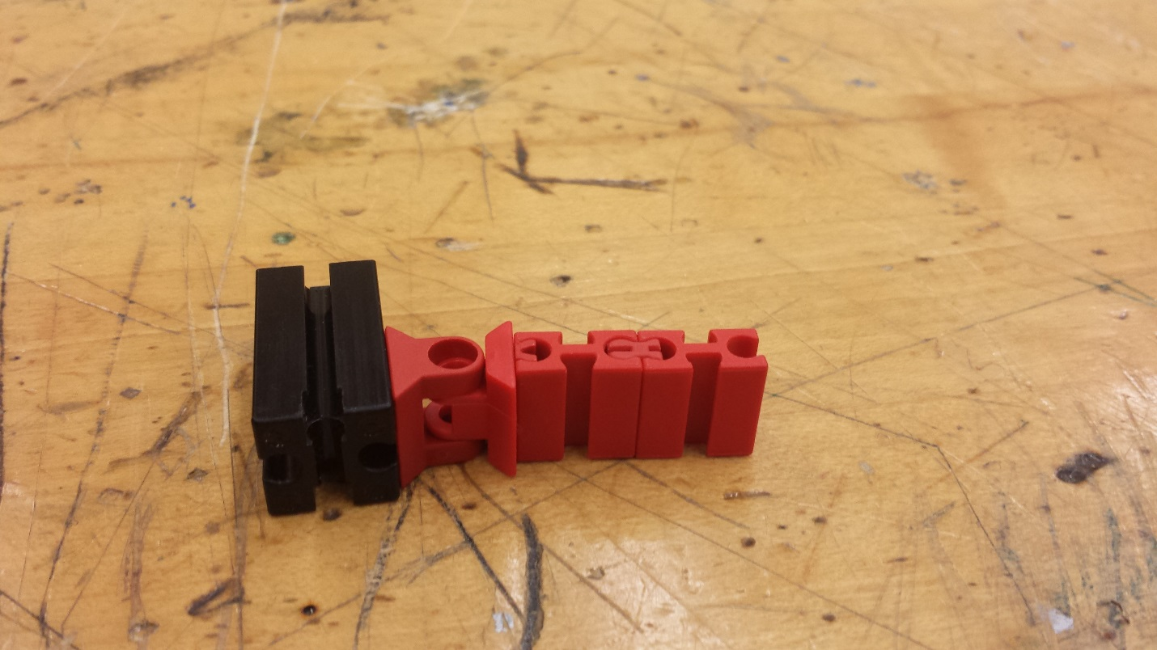

**Attach the hinge block to block 30**

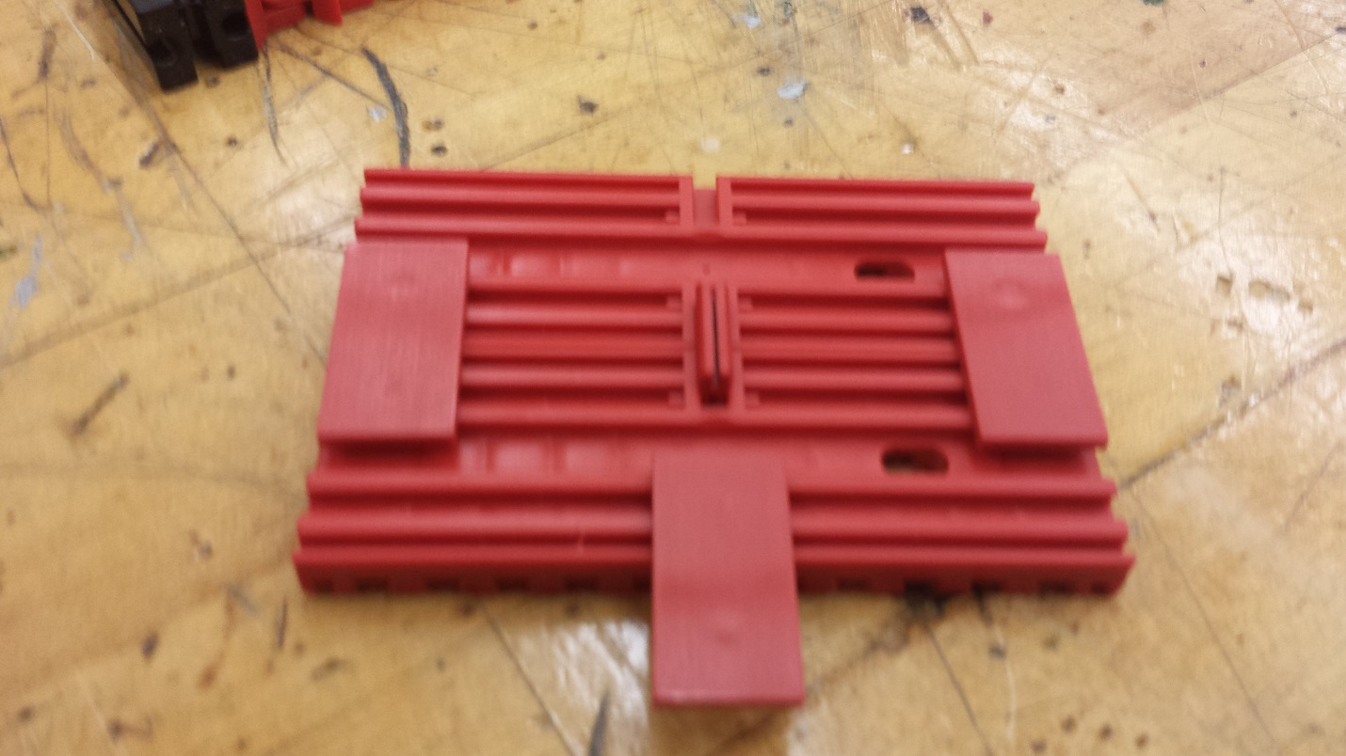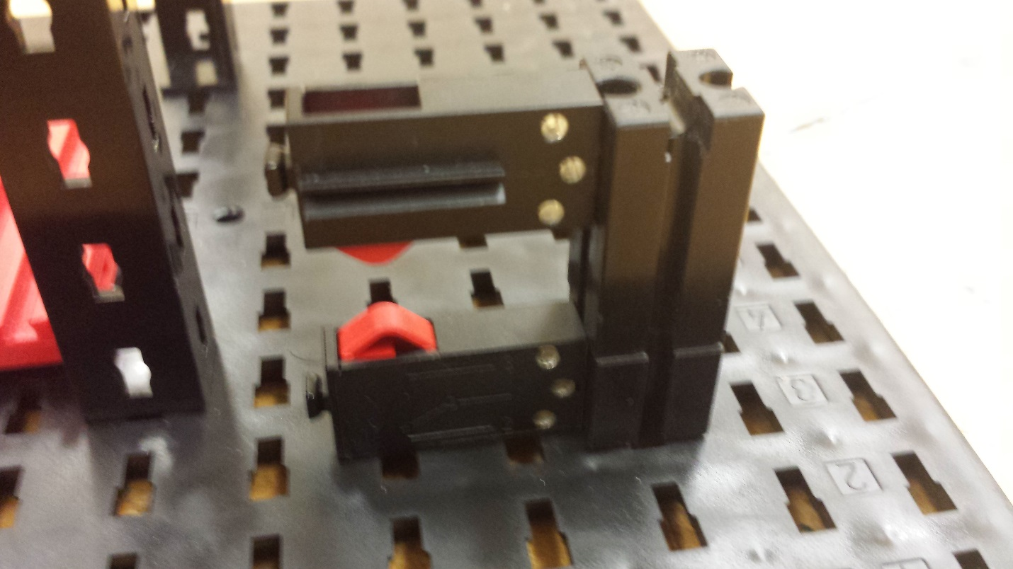

**Attach another Mounting Plate with Peg 15 X 45 for attaching the platform to the base**

**Attach two Bottom plate 30 X 90 using two Mounting Plate with Peg 15 X 45**

**Attach the a block 30 to a block 15**

**Attach two limit switches on the top and bottom of the pillar as triggers**

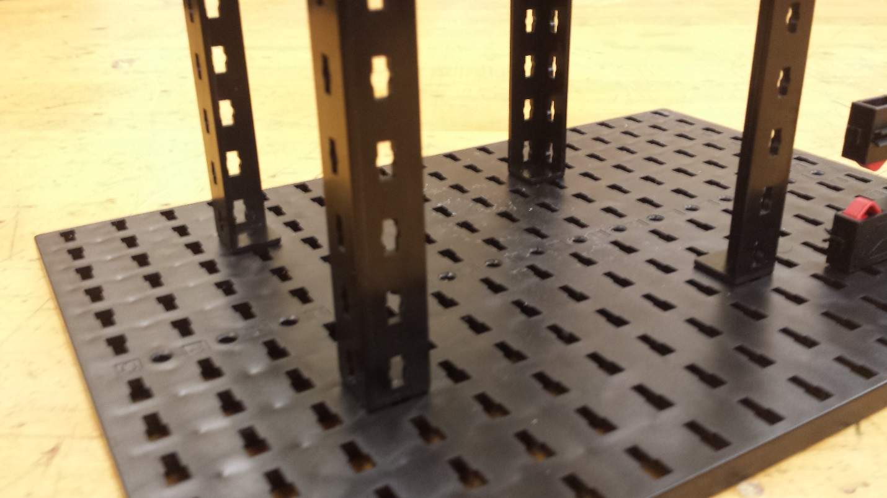

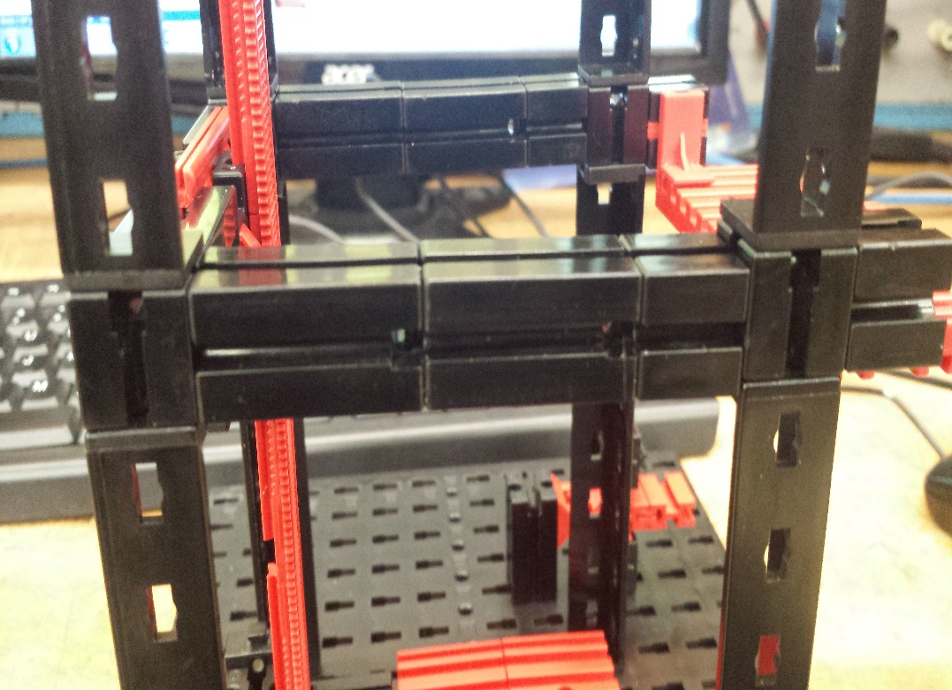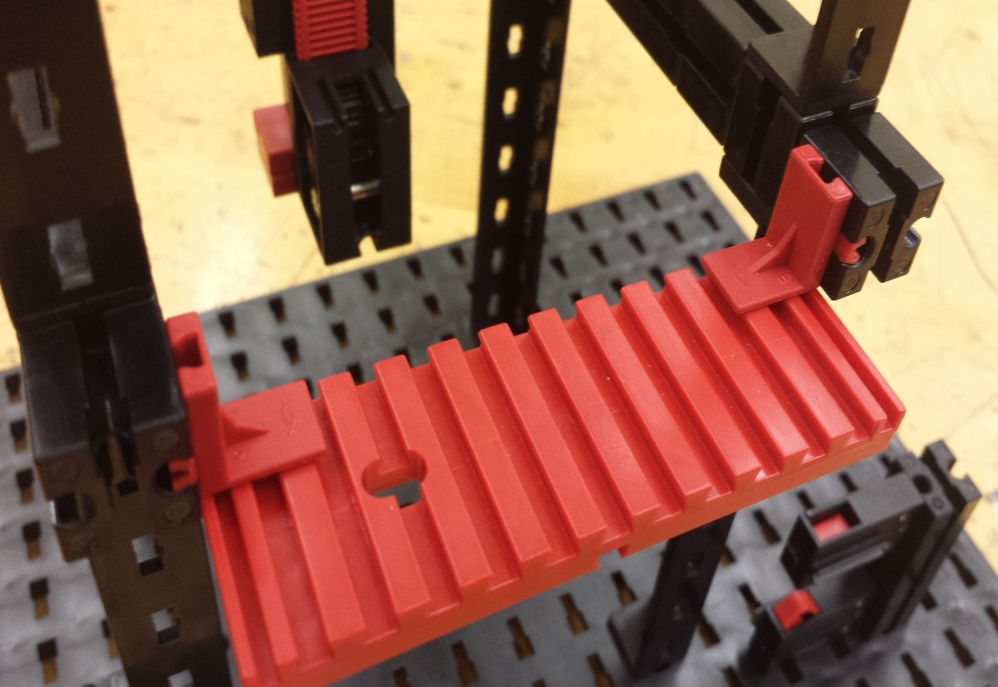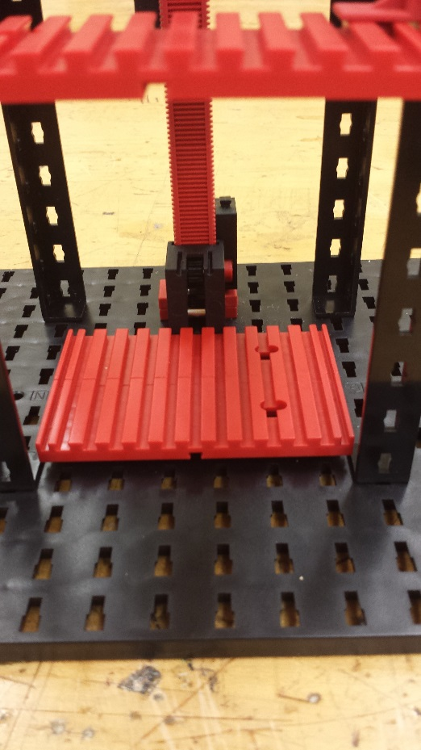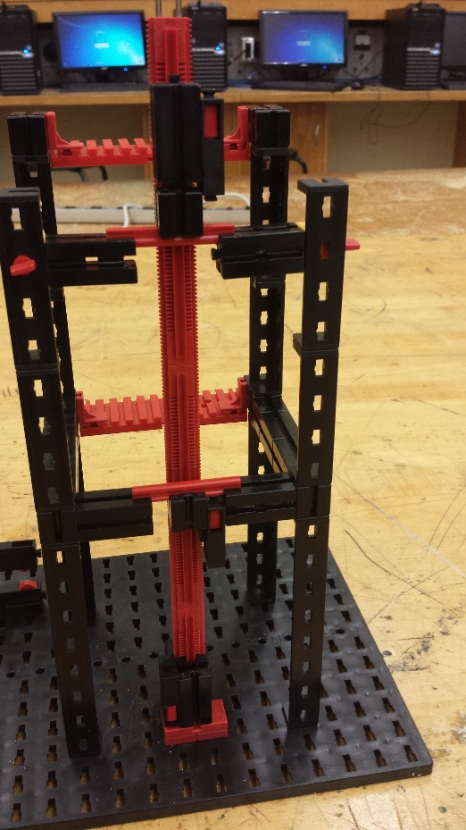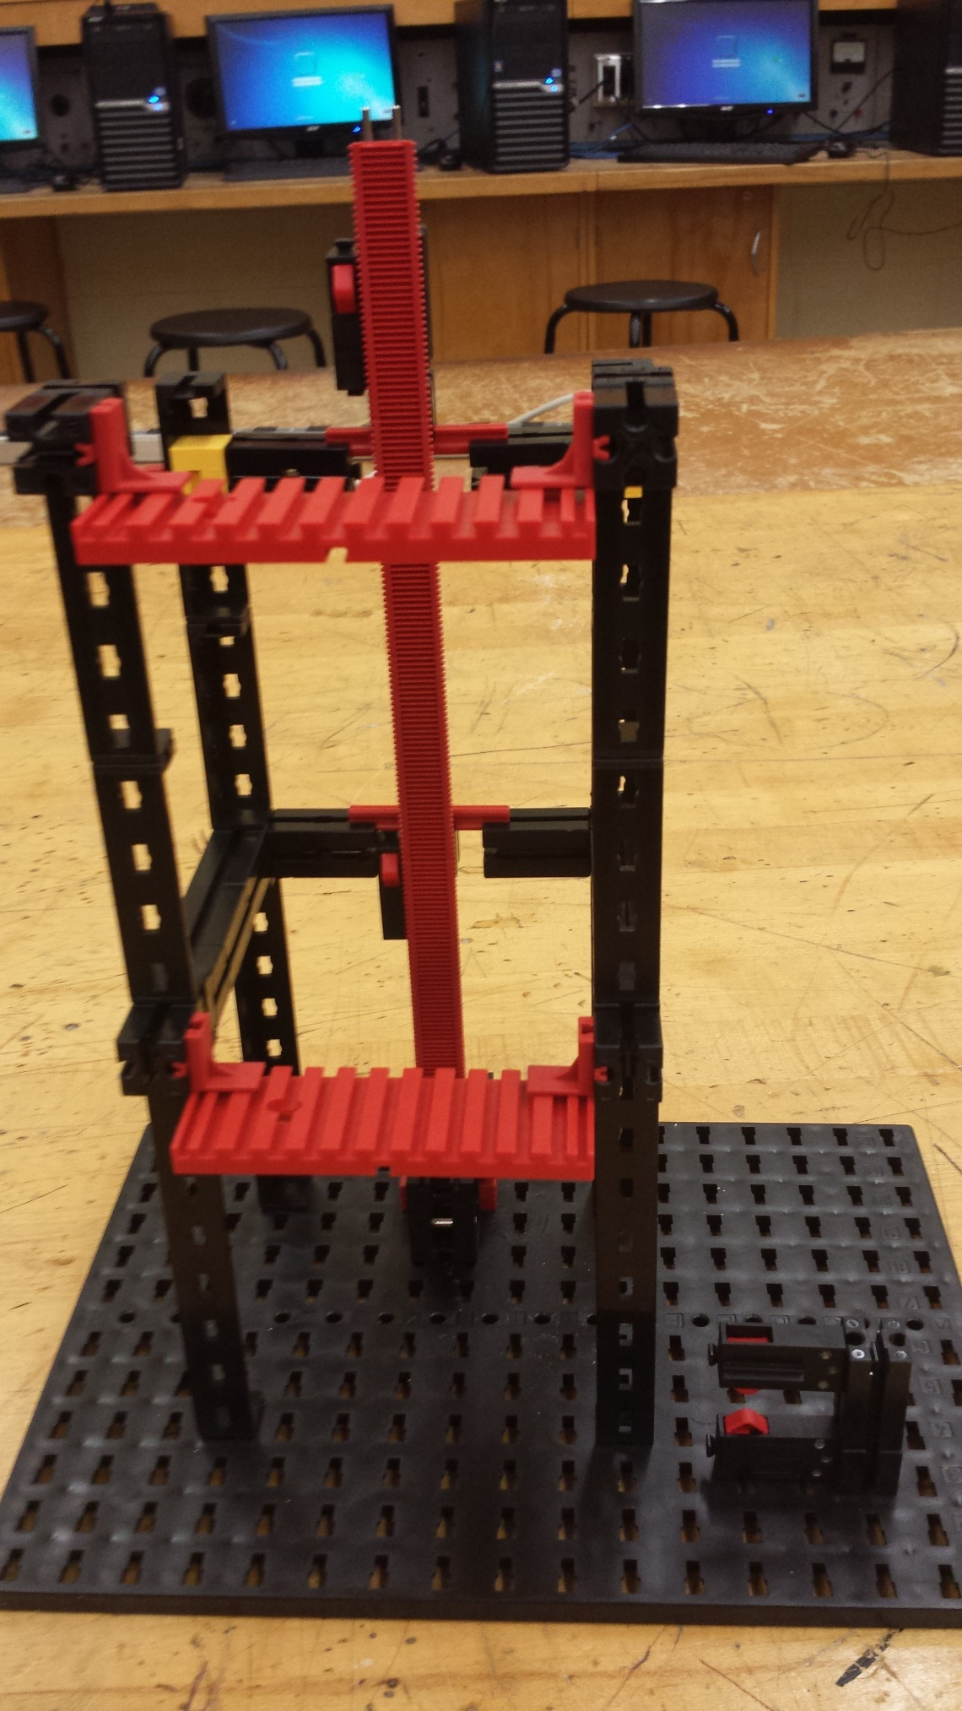

**Do the same thing for the top level**

**Place 4 girder 120 on N4, G4,   
N10, G10**

**Place one block 15 over the girder 120 and place another set of girder 120 on top of block 15**

**Using 2 block 30 and one block 15 attach the two post on either side**

**Attach a block 15 to the side supports**

**Attach building plate 30 X 90 to the block 15 on either side**

**Pass a gear box through the rails and Attach a motor on the gear box**

**Attach the platform to gear box**

**Attach two building blocks 5 with 2 pins to building plate and Attach the plate on to a block 30**

**Place the Plate on J10, K10**

**Attach a limit switch on each level**

**Attach two block 30 on either side and Attach them using link 30**

**Attach two block 30 on either side using statics block for support**

**Using rivets attach statics blocks to the girders for support platforms**

**Attach the 5 rack and pinions together to make a rail for the platform and Attach them to the back of the supports**

**Your final model should look like this**

|  |
| --- |
| Wiring |

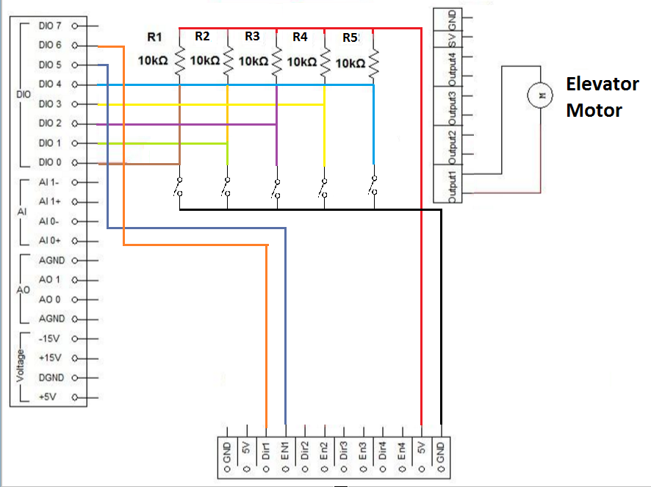

|  |
| --- |
| Program |

Before beginning, take a look at the flowchart below to understand the process and logic behind the Garage Door program.

G:\Downloads\Elevator - LabView.png

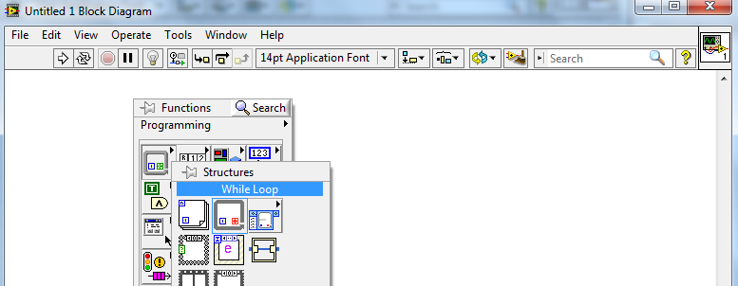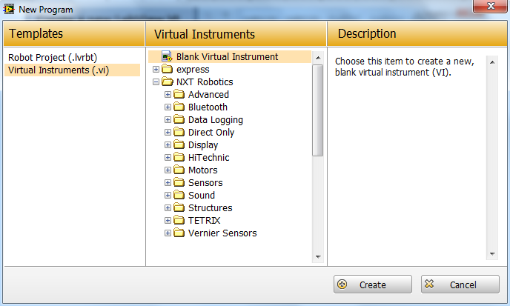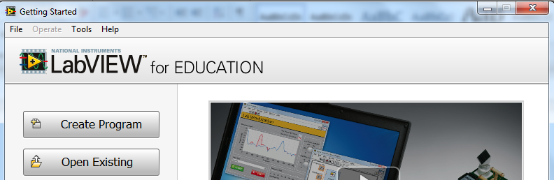

**Select While Loop**

**The block diagram and front panel windows will appear. From the block diagram, right click to open Functions pallet. Go to Structures.**

**Click Create**

**Choose Blank Virtual Instrument**

**Create a new LabView VI**

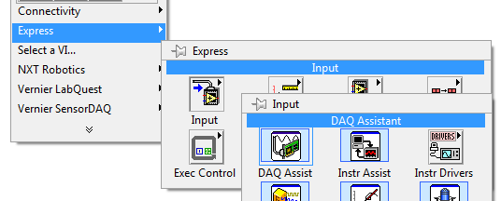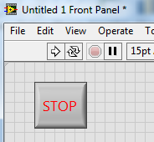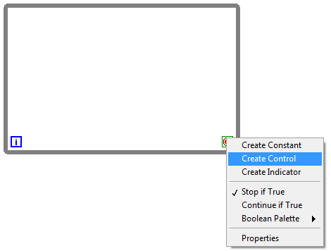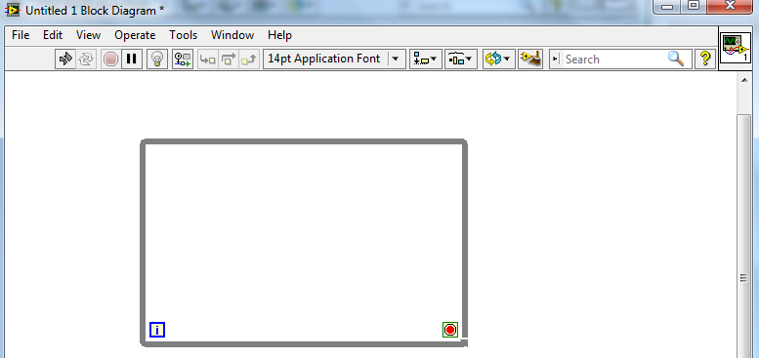

**Select Create Control**

**Right click on the Loop Condition**

**Stop Button will appear on the front panel window. Resize / Style it as you seem fit.**

**Drag mouse to create the while loop**

**You can drag the borders to change the size as you need**

**Select DAQ Assistant**

**Choose Input**

**Open Functions pallet and go to Express**

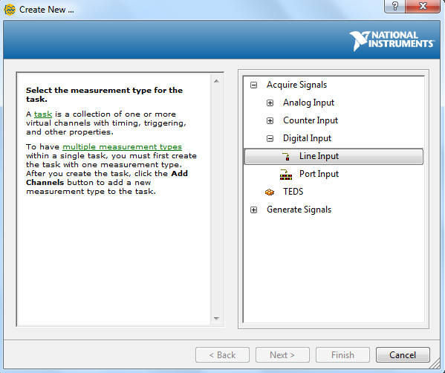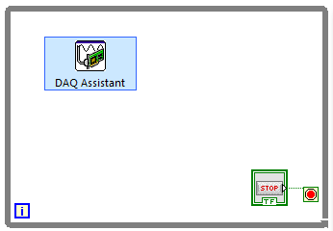

**Select Line Input**

**Choose Digital Input**

**A DAQ Assistant window will appear. Click on Acquire Signals**

**Place DAQ Assistant inside the while loop**

**At this point, make sure that the NI myDAQ device is connected to your computer before proceeding**

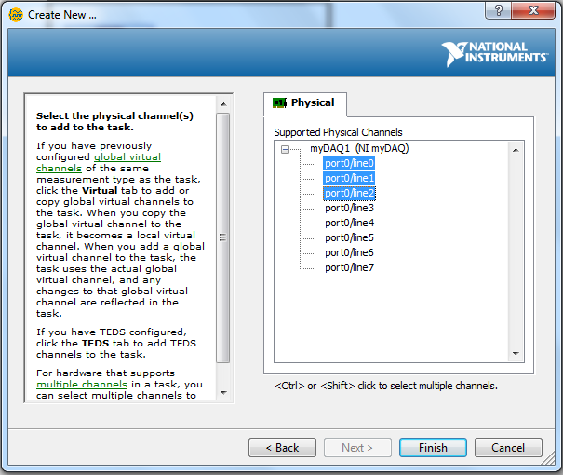

**Select Ports 0, 1 and 2 using the Ctrl Key**

**Your NI device will appear in the list**

**Click Finish**

**If your DAQ device doesn’t appear in the list, make sure to connect it to the computer via a USB. Then close the DAQ window and re-follow the steps to create the DAQ Assistant**

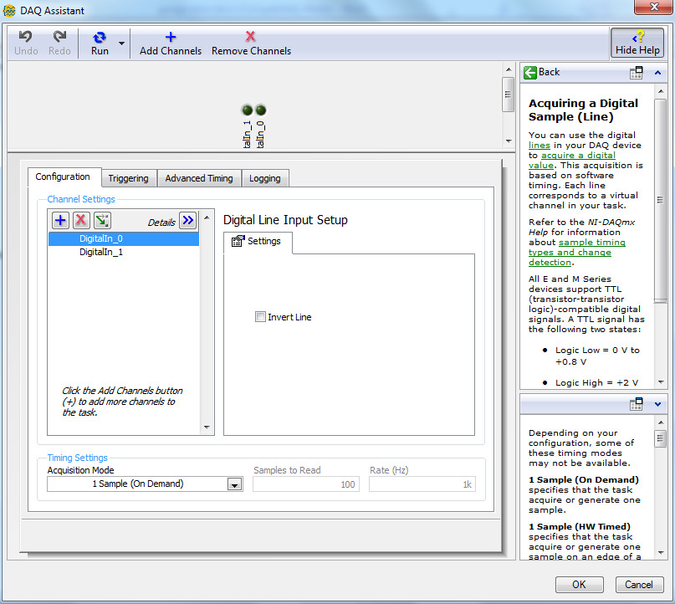

**It is possible to change the speed or rate at which the input is read. Leave it as it is for now.**

**Click OK to finalize the settings**

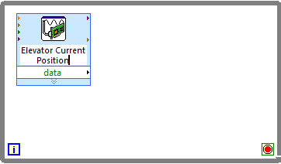

**Double-click to rename the DAQ Assistant to specify its purpose**

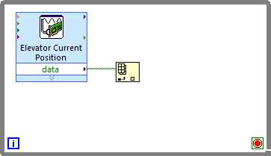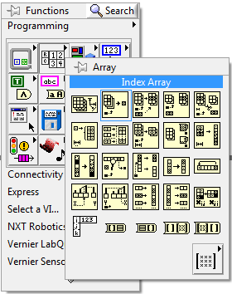

**Connect the data terminal of DAQ Assistant to array terminal of Index Array**

**Open Functions pallet and go to Array**

**Create an Index Array**

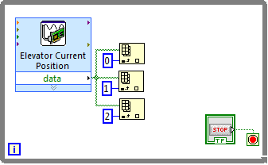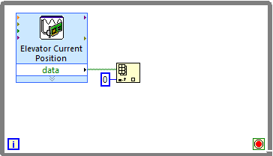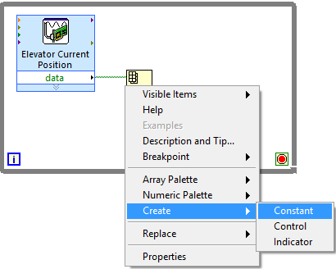

**Give the constant a value of 0**

**Create two more Index Arrays with constants 1 and 2 and connect them in the same way**

**Right click on the index terminal of Index Array**

**Select Constant**

**Click on Create**

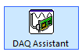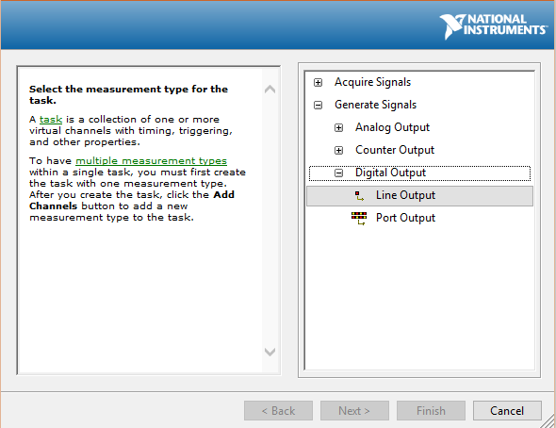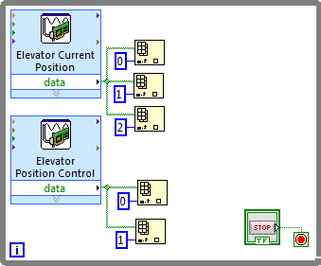

**Create a DAQ Assistant for the Elevator Position Control using digital ports 3 and 4.**

**Connect it to two Index Arrays with constants 0 and 1**

**From the DAQ Assistant window, choose Generate Signals**

**Choose Digital Output**

**Select Line Output**

**Create another DAQ Assistant from the Functions pallet.**

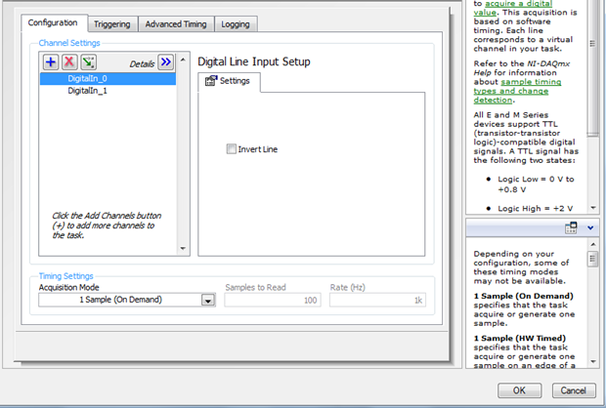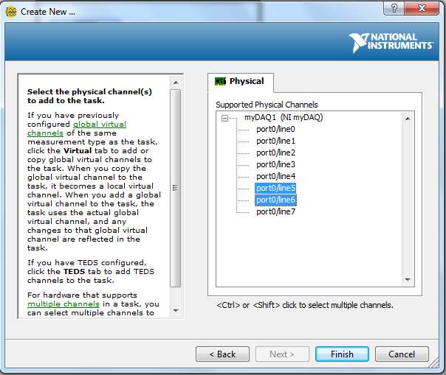

**Select Ports 5 and 6 using the Ctrl Key**

**Leave settings on next window as default and press OK**

**Click Finish**

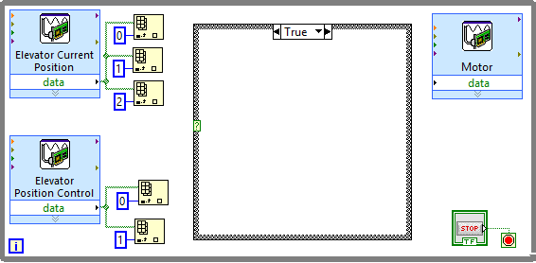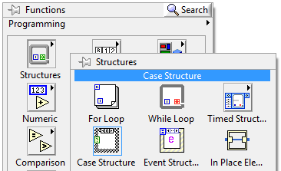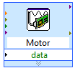

**Place the Case Structure inside the While Loop**

**Open Structures from the Functions pallet**

**Select Case Structure**

**Rename the DAQ Assistant to specify its purpose**

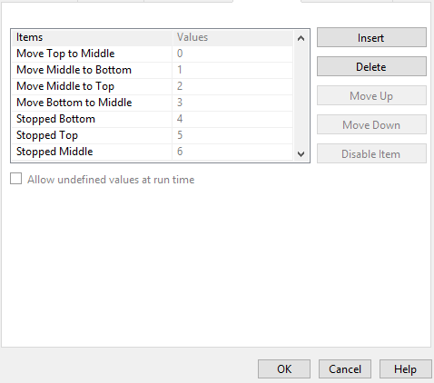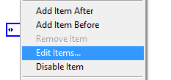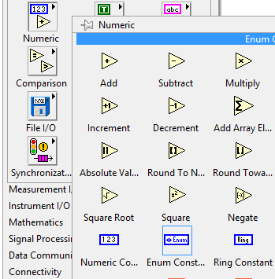

**Create an Enum Constant**

**Open Numeric from the Functions pallet**

**Press OK when done**

**Use the Insert button to add the shown items to the list**

**Select Edit Items…**

**Right click on the Enum Constant**

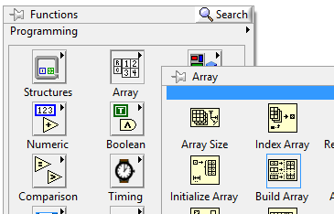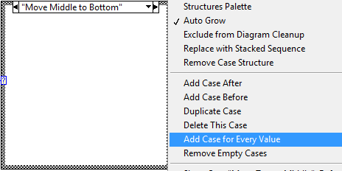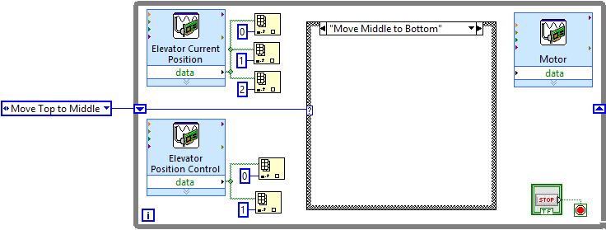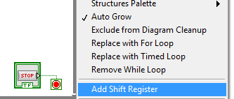

**From the Functions pallet, go to Array**

**Create a Build Array**

**Select Add Case for Every Value**

**Right click on the border of the Case Structure**

**Connect it to the Case Structure inside the While Loop via the Shift Register**

**Place the Enum Constant outside the While Loop**

**Select Add Shift Register**

**Right click on the border of the While Loop**

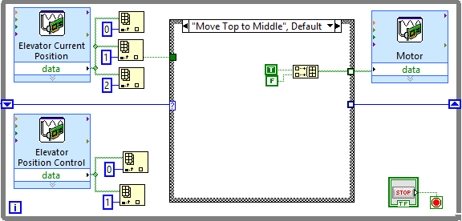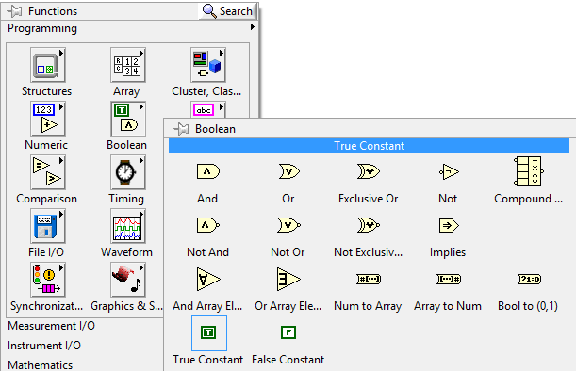

**Place the Build Array and the True/False Constants inside the Case Structure. Connect the True and False Constants to the Build Array and connect the Build Array to the Motor DAQ Assistant**

**Switch the Case Structure statement to Move Bottom to Middle**

**Note: It’s a best guess that True Constant will give the direction to move up. You must test this for yourself and decided whether to use a True Constant or a False Constant.**

**Go to Boolean from the Functions pallet**

**Create a False Constant**

**Create a True Constant**

**Expand the size of Build Array from its bottom border to create another array element**

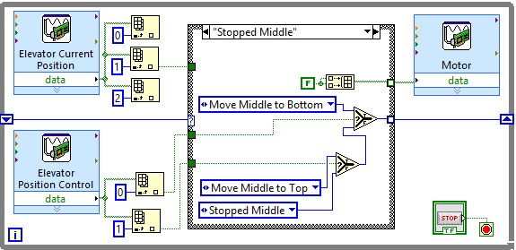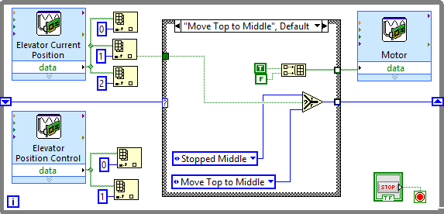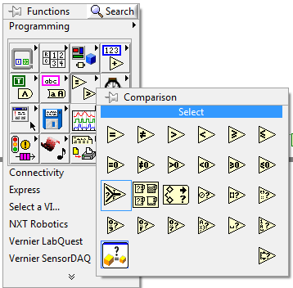

**Set up its inside as shown**

**Switch the Case Structure statement to Stopped Middle**

**Copy the Enum Constant made previously to create two more. Change one of them to Stopped Middle**

**Connect the Select block to the Shift Register**

**Set up connections to the Select block as shown**

**Go to Comparison from block diagram Functions pallet.**

**Create a Select Block**

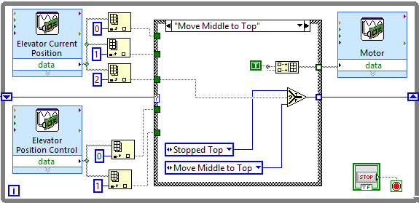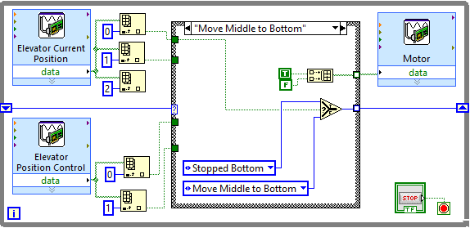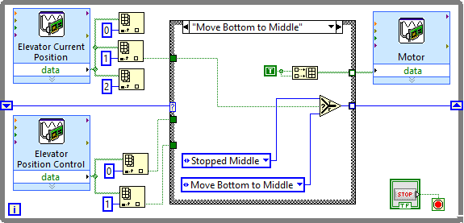

**Set up the four remaining Case Structure cases as shown in the next four diagrams**

**Set up the Move Bottom to Middle case statement as shown**

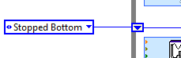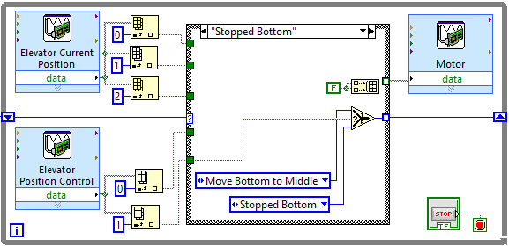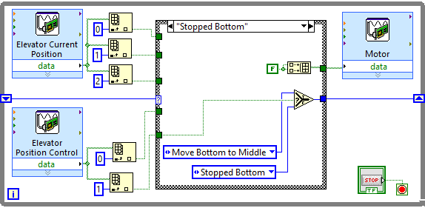

**Change the value of the Enum Constant outside the While Loop to Stopped Bottom. This is the position that the Elevator originally starts at.**

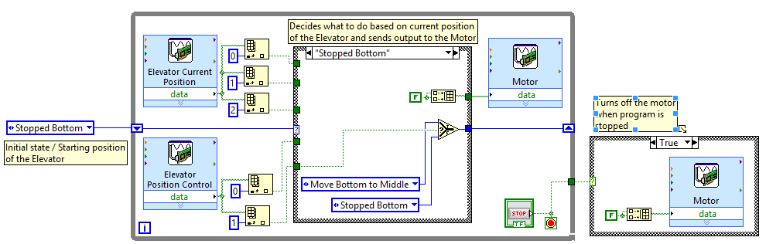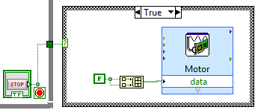

**Create a Case Structure from Functions pallet. Place it outside the While Loop. Set it up as shown in this diagram.**

**Connect the Case Structure to the Stop Button Control**

**Congratulations, your LabView VI is now complete. You may wish to add comments to specific portions of your program so that others can more easily understand it. You can do this by double-clicking at an empty space on the block diagram.**

|  |
| --- |
| Present |

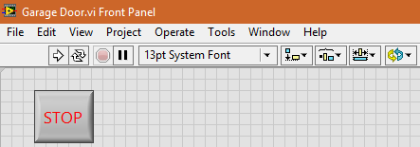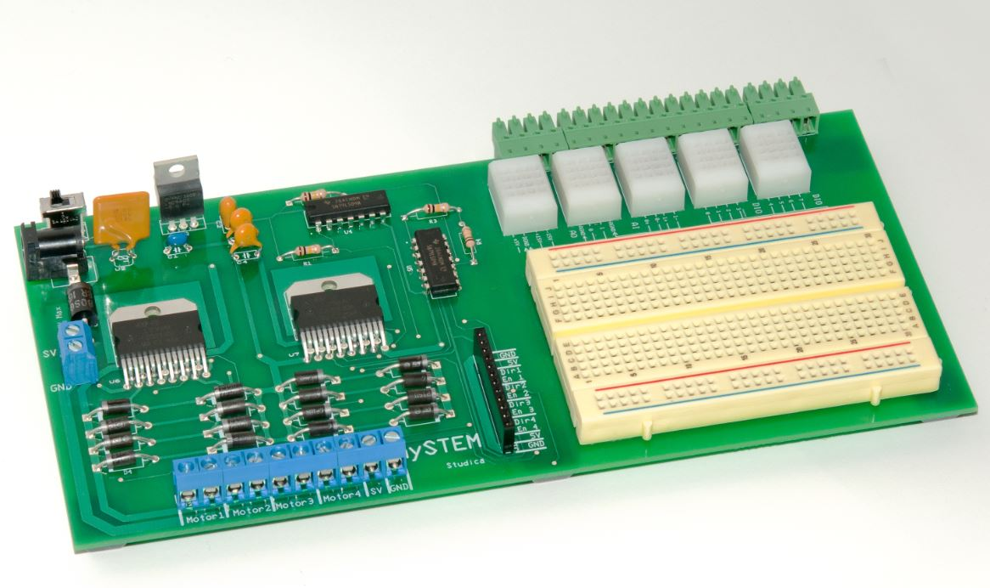

**Press the Stop Button on the front panel after you are done**

**Test your final system before showing it for evaluation. Make sure it works as you would expect. If you find something wrong, refer back to the steps in this tutorial and see if you followed them properly.**

**Make sure it is connected to an external power source**

**Make sure your mySTEM board is turned ON**

**Click the Run button on the toolbar to start the program**